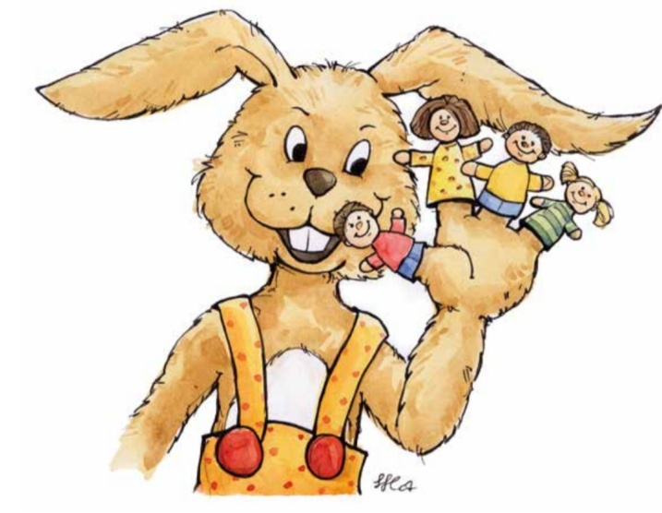

JĘZYK NIEMIECKI
6.04 – 9.04.2021
TEMAT TYGODNIA: SPORT

PROPOZYCJE NA TEN TYDZIEŃ
Nowa piosenka
https://l.facebook.com/l.php?u=https%3A%2F%2Fm.youtube.com%2Fwatch%3Fv%3Do-mybJKgcVk%26fbclid%3DIwAR029aoqU3kpIV9R8e7Lub87lrU33vg0XdZFx9Rgd-97Cd0V8xsI5vecktk&h=AT0Jy9DKuZB5sLmKcJjgcBcvAZYh_dw1pzh2W8QVelSHVmKdkoPRE7N48oLZAj0l6h0J8Ud6TuZJnYz0ENvocfTNHVWMgPKuKiHVKk6cc4ttBj57KyDGYsav5YSYO7O7m75m49I71UCePsbBSJE

Zabawy ruchowe do już znanych piosenek – utrwalenie
Tschu Tschu wa - Singen, Tanzen und Bewegen || Kinderlieder - YouTube

https://l.facebook.com/l.php?u=https%3A%2F%2Fyoutu.be%2FiXFAunwnIxE%3Ffbclid%3DIwAR3X48cphq7svPu85sgLhwsSywgnec00nru2VIXqxiTSuqzxY5FQ5S3bOKA&h=AT0Jy9DKuZB5sLmKcJjgcBcvAZYh_dw1pzh2W8QVelSHVmKdkoPRE7N48oLZAj0l6h0J8Ud6TuZJnYz0ENvocfTNHVWMgPKuKiHVKk6cc4ttBj57KyDGYsav5YSYO7O7m75m49I71UCePsbBSJE

https://l.facebook.com/l.php?u=https%3A%2F%2Fm.youtube.com%2Fwatch%3Fv%3Do-mybJKgcVk%26fbclid%3DIwAR029aoqU3kpIV9R8e7Lub87lrU33vg0XdZFx9Rgd-97Cd0V8xsI5vecktk&h=AT0Jy9DKuZB5sLmKcJjgcBcvAZYh_dw1pzh2W8QVelSHVmKdkoPRE7N48oLZAj0l6h0J8Ud6TuZJnYz0ENvocfTNHVWMgPKuKiHVKk6cc4ttBj57KyDGYsav5YSYO7O7m75m49I71UCePsbBSJE
https://l.facebook.com/l.php?u=https%3A%2F%2Fm.youtube.com%2Fwatch%3Fv%3DWjQhHvw1obU%26fbclid%3DIwAR0gClTFESSdNJlR8qvVilvhLoEFC-fhU4wWkq5BqkwRjNjz5mh0u2VgKIg&h=AT0Jy9DKuZB5sLmKcJjgcBcvAZYh_dw1pzh2W8QVelSHVmKdkoPRE7N48oLZAj0l6h0J8Ud6TuZJnYz0ENvocfTNHVWMgPKuKiHVKk6cc4ttBj57KyDGYsav5YSYO7O7m75m49I71UCePsbBSJE

