08.04.2021
TEMATYKA TYGODNIA : CHCĘ BYĆ SPORTOWCEM

DZIEŃ DOBRY
1. ROZGRZEWKA

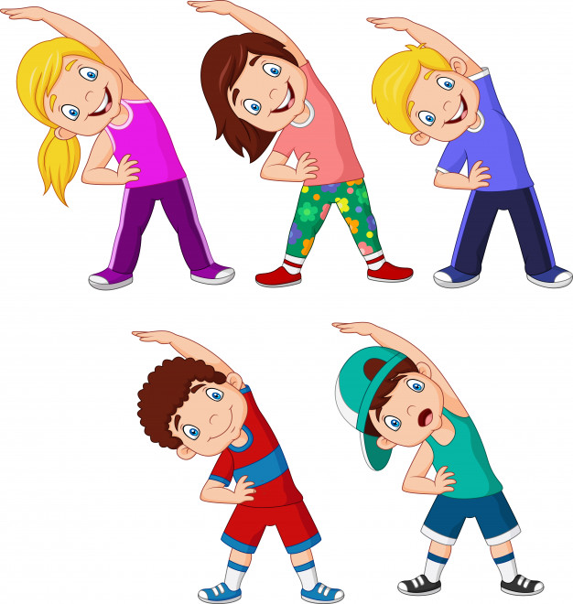

PORANNA GIMNSATYKA Z KUBUSIEM

https://l.facebook.com/l.php?u=https%3A%2F%2Fm.youtube.com%2Fwatch%3Fv%3D52griSsio5Y%26list%3DPLHBtE00YU3ml4rNXagZZU78IqJwMST71d%26index%3D5%26fbclid%3DIwAR2NNNObBGpdZFwlzTb1owHJnwRnBV0oPcciZ6MI87hqU34TwZxKMqjTg50&h=AT0Jy9DKuZB5sLmKcJjgcBcvAZYh_dw1pzh2W8QVelSHVmKdkoPRE7N48oLZAj0l6h0J8Ud6TuZJnYz0ENvocfTNHVWMgPKuKiHVKk6cc4ttBj57KyDGYsav5YSYO7O7m75m49I71UCePsbBSJE
Ćwicz z Kubusiem – Rozgrzewka w parku - YouTube
https://l.facebook.com/l.php?u=https%3A%2F%2Fm.youtube.com%2Fwatch%3Fv%3DmOOW7T3LnzQ%26list%3DPLHBtE00YU3ml4rNXagZZU78IqJwMST71d%26index%3D1%26fbclid%3DIwAR3bf01kP4diiB4Upi5CwCVXEuiMdnkk5L_Kgyy2IEnBxu4mm26P8vN2LZM&h=AT0Jy9DKuZB5sLmKcJjgcBcvAZYh_dw1pzh2W8QVelSHVmKdkoPRE7N48oLZAj0l6h0J8Ud6TuZJnYz0ENvocfTNHVWMgPKuKiHVKk6cc4ttBj57KyDGYsav5YSYO7O7m75m49I71UCePsbBSJE

https://l.facebook.com/l.php?u=https%3A%2F%2Fm.youtube.com%2Fwatch%3Fv%3DHyNxfTcCkCQ%26list%3DPLHBtE00YU3ml4rNXagZZU78IqJwMST71d%26index%3D2%26fbclid%3DIwAR3uj2ZEWx0SFemh-sH1imlINjFTWO3sdIts3Ov37On-d-3H7PPlZx2qCls&h=AT0Jy9DKuZB5sLmKcJjgcBcvAZYh_dw1pzh2W8QVelSHVmKdkoPRE7N48oLZAj0l6h0J8Ud6TuZJnYz0ENvocfTNHVWMgPKuKiHVKk6cc4ttBj57KyDGYsav5YSYO7O7m75m49I71UCePsbBSJE

MM

